Building Stronger Communities

Dave Watson

August 2020

Table of Contents

Executive summary 2
Introduction 5
What is a community? 5
Impact of austerity 6
Social infrastructure 9
Public service reform 13
Public health 16
Local economies 18
Sustainable communities 24
Funding communities 26
Local democracy 28
Conclusion 30

Executive Summary

- The COVID-19 pandemic has highlighted the importance of strong communities, supporting and looking out for each other. This paper looks at how communities of place have been undermined by austerity and make the case for a comprehensive programme to rebuild communities as the building block of a more equal, democratic, healthier and sustainable society.

- Most of us have a vague notion of what we mean by our community. It is usually recognised as a community of place – our village, town or part of a city. There are also communities of interest or identity which join us by our hobbies, work, religion and other interests, which often have no territorial relationship. Communities demand a sense of shared obligation and commitment, something both emotional and practical.

- Austerity has undermined many of the local institutions that bind our communities together. Cuts to our libraries, community learning, youth work, day centres and grants to voluntary organisations have all contributed to a weakening of local communities. These cuts impact adversely and more acutely on the most disadvantaged individuals, communities and groups.

- A key concept in this paper is that of social infrastructure. The Scottish Government reports on a related concept, ‘social capital’. Social infrastructure relates to the physical conditions that determine whether personal relationships can flourish. When social infrastructure is robust, it fosters contact, mutual support, and collaboration among friends and neighbours. When degraded, it inhibits social activity, leaving families and individuals to fend for themselves. We look at a wide range of initiatives that can strengthen social infrastructure including, good housing, libraries, leisure facilities, voluntary organisations, community ownership and the role of planning.

- Communication technologies and social media, in particular, can strengthen and weaken social infrastructure. At its worse, it creates insular ‘echo chambers’. At its best, it directs us to physical spaces that everyone can access and enables ‘Groupsourcing’ fast responses to local need. This also depends on connectivity which can be limited and unequal in many communities.

- The governance of public services in Scotland is one of the most centralised in Europe. We make the case for national government to focus on setting frameworks, leaving the delivery of services to local democratic control. Local integrated services should be based around community hubs in recognisable communities of place. The pandemic has highlighted the importance of local services and the workers who deliver them - we should ‘Build Back Better’ based on the principle of subsidiarity.

- There is a wealth of evidence that place impacts on health and wellbeing and contributes to creating or reducing inequalities. Sufficient social infrastructure helps tackle isolation and improves physical and mental health. This includes how we design communities and create integrated local health and care services.

- Scotland’s high streets and town centres were struggling even before the pandemic with five stores a week closing. We look at the various initiatives to repurpose our town centres in Scotland and across the UK and the proposals from the retail employers and trade unions. Community Wealth Building should be at the core of the measures needed to rebuild local economies, based on wellbeing and inclusion. We need to rethink our town centres as places where people live and work, not just shop, although that will remain important. This requires a much larger regeneration programme that redevelops redundant retail spaces and car parks into homes, workplaces, community hubs and social spaces.

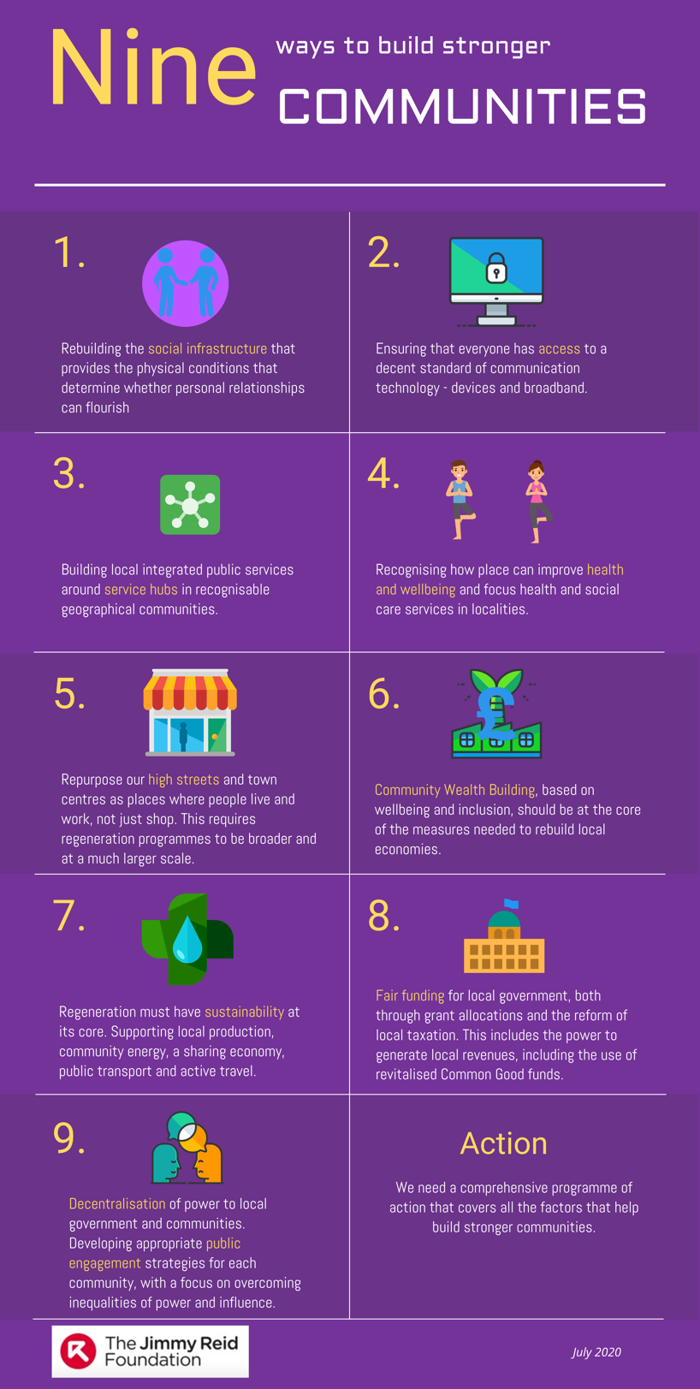
- The measures taken by governments to contain the pandemic have resulted in some breathing space for the environment. Most notably it will have saved some of the estimated 2,500 unnecessary deaths each year from air pollution in Scotland. Stronger communities have to be sustainable communities, based on more local (particularly food) production, community energy, developing a sharing economy, better public transport and support for active travel.

- Given the impact of austerity, stronger communities require fair funding for local services. In addition to a fairer allocation of grant support, the reform of both the council tax and business rates is long overdue. Also, we look at other options for local funding, including local levies for revitalised Common Good funds and the taxation of digital services. Regional banking, commonplace in Europe, would keep money in communities and enable local lending in response to business needs.

- Local democracy should sit alongside measures to decentralise powers and democratise the economy. A fairer Scotland where we care about each other, where people can pool their resources, demand accountability, build institutions and influence the decisions that affect them. We examine the many initiatives taken to strengthen local engagement. They start from the premise, confirmed in polling, that people want to be more engaged, but generally don’t feel part of the decision-making process. The challenge has been to overcome inequalities of power and influence – ‘hard to reach’ is often also ‘easy to ignore’.

- In conclusion, this paper argues that stronger communities will not happen by accident or by more political rhetoric. We need a comprehensive programme of action that covers all the factors that help build stronger communities.

About the author
Dave Watson was the head of policy and public affairs at UNISON Scotland until his retirement in September 2018.
Dave has written extensively on public service reform including previous Jimmy Reid Foundation papers: ‘Public Service Reform’ (2017) and ‘Municipal Socialism for Modern Scotland’ (2018). As a public sector union official for over 36 years, he has been involved in most of the public service reforms of recent times. He has served on a health authority and other public bodies and was seconded to the Health Department to implement the new devolved government’s first HR strategy.
His other publications include: ‘Keir Hardie and the 21st Century Socialist Revival (2019); ‘What Would Keir Hardie Say?’ (2015); ‘Red Paper on Scotland’ (2005); ‘Class, Nation and Socialism’ (2013); ‘Time to Choose’ (2013); ‘Towards the Local’ (2014).
Dave has been a government advisor on public service reform, health and energy policy. He was an expert advisor to the Christie Commission that set the current framework for public service reform in Scotland.
A graduate in Scots Law from the University of Strathclyde, Dave is the Secretary of the Keir Hardie Society, a board member of the Jimmy Reid Foundation, Secretary of the Socialist Health Association Scotland and a Fellow of the Royal Society of Arts.
Born in Liverpool, he spent his teenage years in London, before working for UNISON in Wales, Dorset and 30 years in Scotland. He lives in Ayrshire and is currently working on policy development and consultancy projects.
Twitter: @unisondave. Blog: http://unisondave.blogspot.com

Introduction

Of all the areas impacted by a decade of austerity economics, communities of place have been one of the hardest hit. When difficult decisions have been made on funding priorities, local services have suffered the most. This paper argues that local social infrastructure, like libraries, community learning and voluntary organisations fosters contact, mutual support and collaboration among friends and neighbours. They are the glue that supports our communities.

This paper was largely written during the Covid-19 crisis. This crisis highlighted the importance of strong communities, supporting and looking out for each other. In the main, people and communities across Scotland stepped up to the plate. Even the Tory Prime Minister made a point of saying that there is such a thing as society, in a deliberate attempt to distance himself from the Thatcher doctrine.

There will undoubtedly be many lessons to be learned from the crisis. It will also have a long-term impact on the economy of local communities. In some cases, this will exacerbate the pre-crisis trends, but in others, it will reinforce the importance of place in our social, cultural and economic lives. Overall, we must ensure that the lessons are learned. These are the importance of community, the impact of globalisation and the vital role of the state, local and national, when nothing else stands between the people and penury or even death.

In this paper, I will look at how communities of place have been degraded by austerity and what impact that has had on social isolation, the local economy, and public health. The focus of the paper will be on what we can do to build stronger communities. Many of the issues in this paper have been the focus of often small-scale individual initiatives across Scotland. After the pandemic, we need a comprehensive programme to rebuild communities as the building block of a more equal, democratic, healthier and sustainable society.

What is a community?

Most of us have a vague notion of what we mean by our community. It is usually recognised as a community of place – our village, town or part of a city. There are also communities of interest or identity which join us by our hobbies, work, religion and other interests, which often have no territorial relationship. To belong to a group or a place, in a way that is psychologically meaningful, requires more than a shared interest. It demands a sense of shared obligation and commitment, something both emotional and practical. In modern societies connected (assuming access to technology) individuals may inhabit multiple online communities of interest, but arguably these connections are often transitory compared with physical communities, based on where they live and work.

McMillan and Chavis identified four elements of what they call a ‘sense of community’ – membership, influence, integration/fulfilment, and a shared emotional connection. They define a sense of community as; ‘a feeling that members have of belonging, a feeling that members matter to one another and to the group, and a shared faith that members' needs will be met through their commitment to be together.’

That is fine as a definition, but why does community matter? Raghuram Rajan in his book ‘The Third Pillar’ argues that community, along with the state and markets, is an essential pillar of society: ‘﻿It helps define who we are. It gives us a sense of empowerment, an ability to shape our own futures in the face of global forces. It also offers us help in times of adversity when no one else will. Of course, the community can also be narrow-minded, traditional, and resistant to change. A successful modern community supports its members even while being more open, inclusive, and dynamic’.
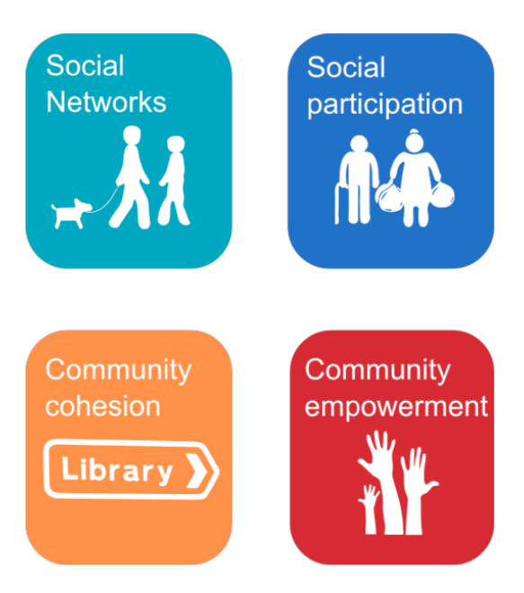
This approach highlights the opportunities that stronger communities can bring, as well as some of the challenges. Some argue that the Covid-19 pandemic may be the dawning of a new grassroots definition of what ‘community’ means in the 21st century. In Scotland and the UK, neighbours looked out for vulnerable people and volunteered to offer support. University students and businesses donated food and equipment to local hospitals, while urban and city dwellers alike stood outside their homes to clap every Thursday for hospital workers. Volunteers are walking the dogs of people they have never met. These varied ways of supporting strangers constitute a definition of community itself, a term which in recent history has become belittled or overused to the point of being meaningless.

Social media connections can be transitory, but the technology can be helpful in supporting and linking up communities. So long as everyone has access to the devices, broadband and the necessary training.

The pandemic has reminded us of the importance of community. While national politicians gave daily briefings, it was local services that delivered in communities. We all gained a new appreciation of the health and care staff, refuse workers, shop workers and many more in our high streets and supermarkets. Together with local voluntary organisations they demonstrated that there is such a thing as community.

Impact of austerity

Austerity has undermined many of the local institutions that bind our communities together. Cuts to our libraries, community learning, youth work, day centres and grants to voluntary organisations have all contributed to a weakening of local communities.

Local government budgets have taken the brunt of austerity. The real terms change outturn figures show that between 2013-14 and 2019-20, the local government revenue settlement decreased at a faster rate (-4.7% or -£517.7 million) than the Scottish Government revenue budget (-2.2% or -£684.9 million) in real terms.. In addition, a significant element of budgets is ring-fenced for central government priorities.

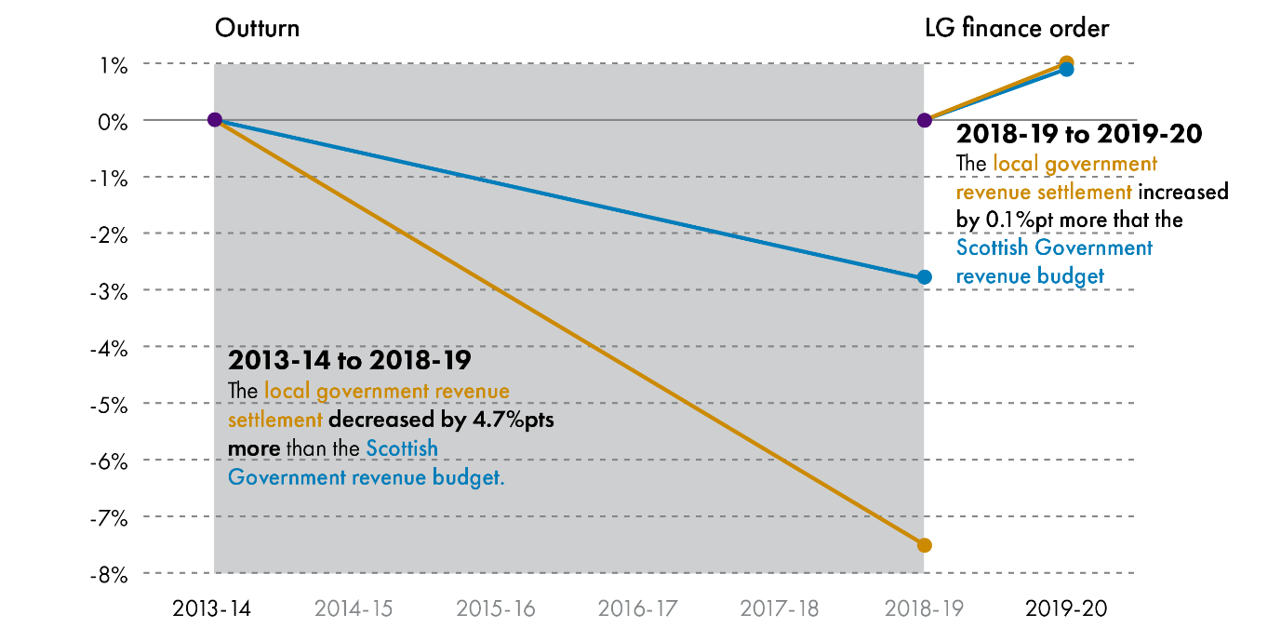

The Local Government Benchmarking Framework report sets out in some detail the impact of austerity on community services. They report:

Across the nine-year period for which we present data, total revenue funding for councils has fallen by 9.4% in real terms (and by 7.6% since 2013/14). Against increasing budgetary pressure, councils have had to manage: growing demographic pressures; increasing national policy and legislative demands, and higher public expectations.

Despite a real reduction in spending of 23.5% since 2010/11, leisure and cultural services have sharply increased their usage rates. During this time there have been substantial increases in visitor numbers across sports (20%), libraries (38%), and museums (30%). Unsurprisingly, public satisfaction rates have fallen for all these services.

Local economic development and planning have seen some of the largest reductions in revenue spending since 2010/11, falling by 28% and 21% respectively. There has been some stabilisation in the last year, and capital expenditure has picked up. Councils procurement spending on local enterprises has increased over the past 3 years, to 28.7% in 2018/19, which is the highest rate recorded so far. Given the pressures on council budgets this is a positive outcome as it suggests that the drive to reduce costs has not resulted in local enterprises being displaced by national suppliers of goods and services.

Despite government initiatives to support the Scottish Living Wage, the proportion of people earning less than the living wage has not reduced significantly, fluctuating between 18% and 19%. This partly reflects the move towards a more insecure labour market, including zero-hour contracts.

Austerity driven welfare reform has also impacted on the poorest in our communities. The 2019 Annual Report on Welfare Reform shows the largest welfare cuts since 2015 are as a result of the benefit freeze, two-child cap, and changes to the work allowance. The findings include:

- 8,500 Scottish families have already had their income cut by the Universal Credit (UC) two-child limit – and that figure will reach 40,000 at full rollout, bringing up to 20,000 children into poverty
- 86% of UC claimants have seen a fall in the amount they can earn before losing UC entitlement
- 91% of Scottish households affected by the Benefit Cap contain children – and the cap has impacted on more than 3,000 households which are losing an average of more than £3,000 per year
- around 5,600 Scottish couples could lose up to £7,000 per year by 2023/2024 because of changes to Pension Credit eligibility

The rollout of Universal Credit has had many administrative problems, and these are likely to be exacerbated by the Covid-19 crisis with huge additional numbers claiming the benefit. The implementation of devolved benefits was moving slowly before the crisis, and some implementation dates have now been deferred. A JRF and Save the Children study showed that more than half of families on Universal Credit or Child Tax Credit in Scotland had been pushed to borrow money since start of the pandemic.

The Scottish Government has been able to mitigate some of the benefit cuts using devolved powers, like the Scottish Child Payment. However, these are modest in scale and divert resources from other devolved services. While the Scottish Government argues that all social security should be devolved, others point to the financial risks in devolving cyclical benefits.

Austerity has also impacted on the ability of the voluntary sector to support communities. Care providers report that funding does not fully cover their costs. Those organisations reporting that the vast majority of their services (over 75%) are sustainable has dropped steadily for the last three years from 57% in 2017 to 39% in 2019. 88% of providers report difficulties in recruiting staff.

More broadly, the annual SCVO survey reports that voluntary organisations expect tough times ahead. 34% think their own finances will worsen, and 75% think that the financial situation for the sector will worsen.

UK austerity measures impact adversely and more acutely on the most disadvantaged individuals, communities and groups. These changes may be understood as representing a shift of responsibility away from collectives to individuals, as public services are cut.

Social infrastructure

Social infrastructure relates to the physical conditions that determine whether personal relationships can flourish. When social infrastructure is robust, it fosters contact, mutual support, and collaboration among friends and neighbours. When degraded, it inhibits social activity, leaving families and individuals to fend for themselves.

The Scottish Government published a report on levels of a similar concept that they call ‘social capital’. Social capital refers to the social connections that contribute to people’s health and safety, as well as their wellbeing in both economic and social terms. The social capital ‘index’, which measures factors such as community empowerment and social participation, has fallen by 5% between 2017-2018, after a period of stability since 2013.

The report finds:

- Twenty-one per cent of people said they experience loneliness regularly.

- Twenty per cent said they feel they have influence over local decisions, meaning 4 out of 5 people feel a lack of influence over what happens in their community.

- People in more deprived areas are 87 per cent more likely to report feelings of loneliness.

- People from deprived areas are also 25 per cent less likely to say they have places to meet and interact.

- Overall, disabled people, people in socially rented housing and people in more deprived areas have higher levels of loneliness and lower levels of social interaction.

The report states that, to increase levels of social capital, it is essential that there are good quality, affordable and accessible places and spaces where people spend time, gather and meet.

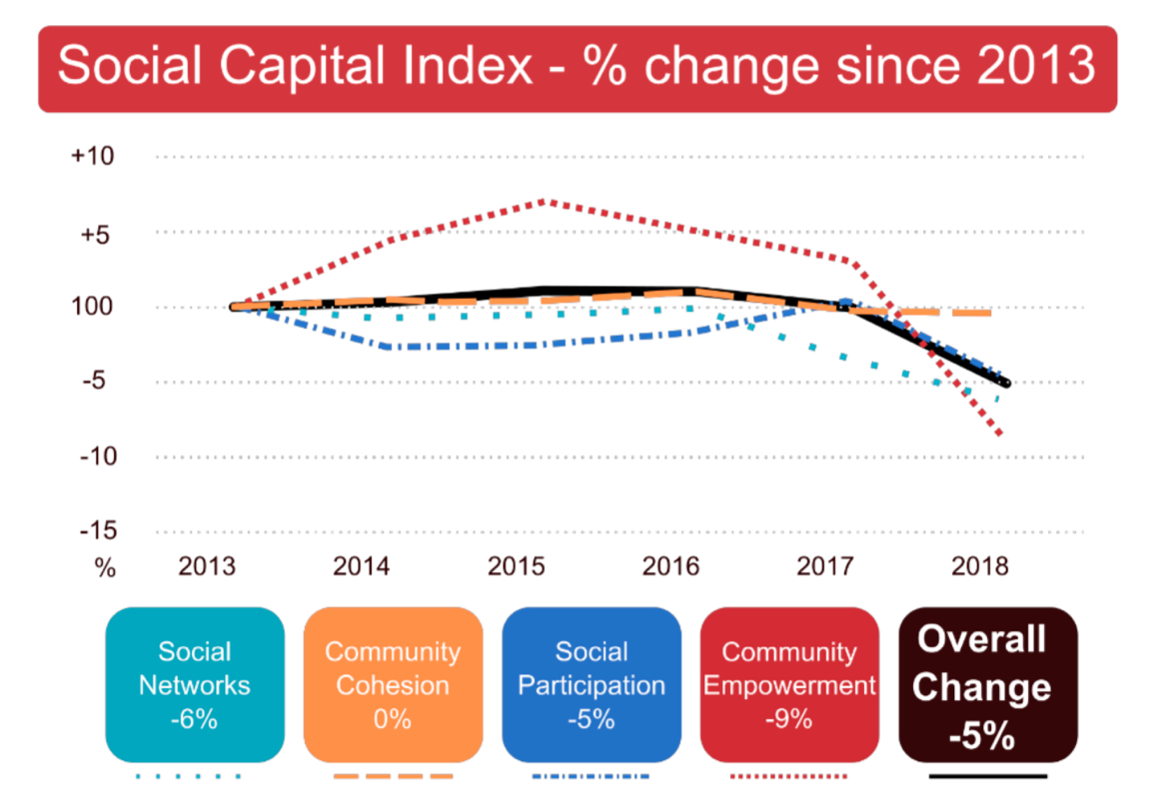

Eric Klinenberg in his book Palaces for the People: How to Build a More Equal and United Society, looked at two districts in Chicago after the 1995 heatwave. They had similar socio-economic characteristics, but one district had a much higher death rate. The difference wasn't cultural or about how much people cared about each other – it was that poor social infrastructure discouraged interaction and impeded mutual support.

Libraries are probably the best example of this. They are accessible and organised by professional staff that uphold a principled commitment to openness and inclusivity. The writer Neil Gaiman described the two closure options in the public consultation on Hampshire’s libraries as disastrous for communities: ‘An open library is proof that we value community and culture. A closed library is a sign of a society – and a county council – that is turning its back on both.’

A café might be social infrastructure, but it depends on the degree of openness, cost etc. Similarly, an early years centre where parents meet up at the same time is social infrastructure, but not a childcare centre in a commercial area where parents pop in and out to match their working hours.

Safe, green spaces are another essential part of social infrastructure. This includes parks and gardens, but also in the design of housing developments. Studies show that the greener the immediate surroundings of a building, the lower the rate of crime. Although this only works when they are well maintained and so used by residents, creating passive surveillance and feelings of greater ownership and control. The pandemic has raised interest in biophilic design, which involves embracing a visual connection with nature through well considered interaction with the outdoors. This can range from adding planted spaces and water features, to installing green walls on building facades, to simply positioning furniture to engage with views.

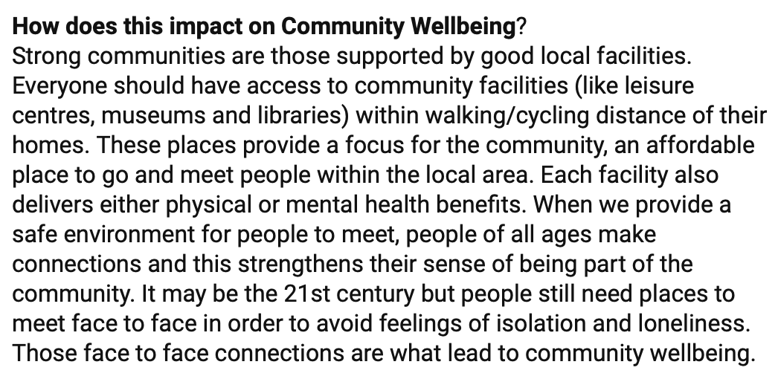
Public sports and leisure facilities have been squeezed due to austerity cuts. In Iceland, they have free swimming pools or ‘hot pots’ that are used by people from all walks of life – one per 2,750 residents. Organised sports can build similar social interaction. In the UK, 80% of people who play organised sport have friends in the organisation, a much higher rate than for other organisations. Along with people who regularly attend church, they are more likely to volunteer in other civic projects.
Comment on Scottish Parliament consultation

Schools and colleges are important elements of social infrastructure. Their facilities could be more widely accessible - breaking down the barriers that private finance schemes have created. We also need to revitalise Community Education, a service that has been decimated during austerity.

Some might argue that this is less important in the internet age. Klinenberg argues that communication technologies work best when they direct us to physical spaces that everyone can access. The excesses of internet culture and the ‘echo chamber' patterns of use, add to the problem. It feeds what social scientists call ‘bonding social capital’, but starves us of the ‘bridging social capital’ we need to live together. Mark Zuckerberg’s vision of Facebook as social infrastructure is flimsy because it cannot give us what we get from churches, unions, sports clubs and the welfare state. The primary aim is to keep us glued to the screens.

The community response to the pandemic has seen a growth in what is sometimes called ‘Groupsourcing’. This is where groups on social networks are created around user needs by the users themselves, rather than being coordinated centrally. Facebook is trying to facilitate this with their ‘community help’ feature. These approaches are faster and more seamless than traditional responses but are not without challenges. Volunteers are handling money from vulnerable people, chemists handing over drugs and the abuse of personal data. We need a conversation about the role of social media in community life, including open and transparent systems.

The use of social media platforms also highlights the importance of broadband connectivity. Not only to expand full-fibre broadband all communities, but also to everyone in the community. Some argued Labour’s British Broadband Service was an unnecessary luxury last December. In the Covid-19 crisis, it looks as much like a necessity as clean water did in 19th century Scotland.

Good housing, which individuals and families can afford, underpins stronger communities. Scottish Labour’s Housing Commission report has highlighted the crisis of housing undersupply and affordability in the public and private sector - alongside a crisis of quality with space, amenity and environmental standards being progressively eroded. The report sets out a detailed ten-part plan based on the underlying principles of tackling inequality in housing and rebalancing the relationship between the private and public sector.

Other reports have highlighted the importance of bringing more housing back into our high streets. While this is important, housing will never build coherent societies without high streets, so housing initiatives must recognise the importance of creating a working community.

A key issue for communities is bringing empty property back into community use. There are an estimated 40,000 Long Term Empty Properties in Scotland (empty for more than 6 months). The Housing Commission proposes using the law to force sales in certain circumstances or a low-cost loan scheme to incentivise re-occupation, especially in rural areas.

The Scottish Government is encouraging greater community ownership, and has included it as a National Indicator. The latest report identifies 593 assets in community ownership, owned by 429 community groups and with a total area of 209,810 hectares, 2.7% of the total land area of Scotland. Part 5 of the Community Empowerment Act also introduces a right for community bodies to make requests to all local authorities, Scottish Ministers and a range of public bodies for any land or buildings they feel they could make better use of.

It remains to be seen if this approach genuinely empowers communities. Another idea is to create a Right to Space to ensure communities have places to meet and funding to build the capacity to participate as active citizens. Giving more power to communities will help create a more preventative approach that tackles problems at source rather than merely managing them once they've happened.

Civil society plays a key role in building social infrastructure and tackling social justice. Urban grassroots initiatives do vital work, raising awareness and taking action on sustainability issues. Run largely by volunteers; they fill important gaps left by the public and private sectors, addressing specific local concerns, empowering individuals and enabling community voices to be heard. But these groups can be limited by time pressures on volunteers, a low level of influence with local government and difficulties in public engagement and enlisting diverse members. These issues are highlighted in the research undertaken as part of the London Soundings Project.

A Labour activist in London started an initiative which shows how communities can build effective networks. Three evaluations have shown that The Cares Family's programmes (now extended to Liverpool and Manchester) reduce isolation, improve relations across the generations and help people to feel happier, closer to community, that they miss other people less, and that they have more people to rely on in times of need. Unions also play an important role in building stronger communities as one of the largest and best organised voluntary organisations. At the local level, union branches strengthen workplaces and play a role in community life. Trade Union Councils bring together trade union branches in communities of place, and can often be seen leading local campaigns.

There is a concern that neoliberals draw on community spirit to further normalise the idea of charity, instead of taxation. On the other hand, the spirit of wanting to help our community is a demonstration of collectivism that can be built on to further a progressive narrative. As Chloe Maclean put it, ‘Amongst all the shit, the building of community relations and collective spirit is a reason to be hopeful.’

The pandemic has reminded us of the pivotal role local authorities can and should play in mobilising and coordinating community volunteering. In many places councils, often working with trusted voluntary sector partners, have got volunteers out supporting the vulnerable quicker than any national initiative, and with a reach and level of targeting that is difficult for self-organised neighbourhood networks to achieve. Retaining this convening and coordinating power will be important if we are to find long-term outlets for the appetite that exists within our communities to help those in need, and which could be applied to a broader range of voluntary action.

The planning function will play an important role in pulling many of these initiatives into a coherent plan. As the post-pandemic debate shifts towards the economic recovery, there will be a pressing need for a strong, well-resourced and strategic plan-led system to provide confidence to local people, investors and businesses, and increase the resilience of places and communities. This requires a renewed emphasis on planning for public health, infrastructure, affordable high-quality housing, active travel, access to services and green space, capturing the benefits of technology and continued action to mitigate the risks of climate change.

Since the 1980s, an anti-tax ideology has whittled down the public funds we need to build and maintain critical infrastructures - austerity has been the last straw. As we replace crumbling physical infrastructure, we should also consider how it might contribute towards strengthening our social infrastructure.

Public service reform

The Christie Commission reported in June 2011 and its key conclusions were that Scotland’s public services require comprehensive reform by empowering communities, integrating service provision, preventing negative social outcomes and becoming more efficient. The principles in this report have formed the basis of public service reform in Scotland over recent years, even if implementation has been patchy at best.

The recommendations of the Christie Commission were mostly about rewiring the system, but it was recognised that could lead to longer-term structural change - based on local democracy, not centralisation. Sadly, the focus of public service reform has championed centralisation and ministerial direction over the principles set out in Christie. There is a detailed analysis of public service reform in Scotland in a previous Jimmy Reid Foundation paper.

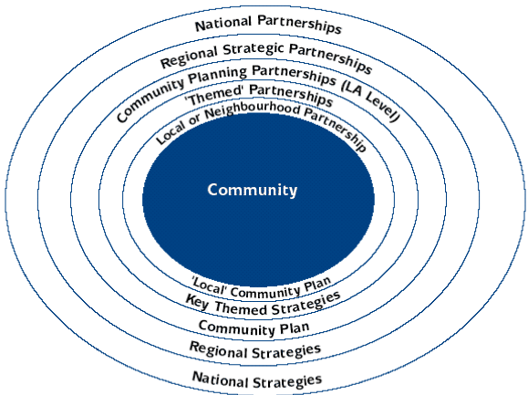
The most significant attempt at local integration has been the introduction of integrated joint boards to direct local health and care services. As with previous attempts at integration, progress has been challenging. As the Accounts Commission Chair said in a recent report: ‘The pace of progress with integration has been too slow and we have yet to see evidence of a significant shift in spending and services from hospitals to community and social care.’

Community Planning is the primary mechanism for planning public services in the area of the local authority after consultation and co-operation with all public bodies ... and community bodies. Community planning is delivered through 32 Community Planning Partnerships, led by the local authority, but including all the statutory agencies and third sector representatives. They should draw in community views through a range of consultative mechanisms.

The rationales behind place-based approaches include:
- the need for higher quality, more responsive services and for communities to deliver more services for themselves (co-production
- the need for improved coordination and more integrated services
- the pressure to devolve more power over resources to front-line staff and the public
- the idea that innovation through place-based approaches can lead to new preventive measures and improved performance.

The risk is that place-based approaches are becoming a catchall for a wide range of policy objectives with the risk of overload.

A number of Scottish local authorities have integrated the delivery of services in recognisable community settings, as outlined in the Jimmy Reid Foundation paper on public service reform. Community hubs, where all, or most services are physically or, where that is practically difficult, virtually delivered. Progress has been limited by capital spending restrictions during austerity, but there are a growing number of examples.
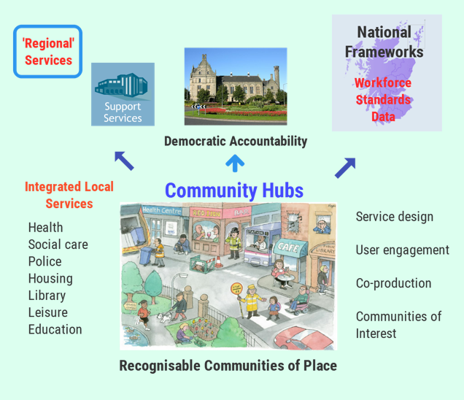
Support services like HR, payroll, finance, could be provided off-site, without creating unnecessary shared services structures. The aim would be to deal with as many user issues as locally possible, not send them into the failure demand of call centres. With a national workforce framework and the single public service worker, workforce matters would be simplified and not have to be replicated in every hub.

Physically siting services together encourages integration and joint working better than any number of liaison committees or other ways of working. Home care staff that identify health issues with their clients can pop into the GP surgery when they get back to the same base. GP practice nurses can introduce patients to leisure facilities on-site, and so on. Public service workers who have done this describe how it improves communication and integration better than all the IT systems they have ever had to master, or more usually that simply don’t work.

Local service design would benefit from the principles set out in John Sneddon's book Systems Thinking in the Public Sector. He argues that ill-thought-out public service reform has led to unwieldy systems of mass production that do little for the people they are supposed to serve.

If the pandemic has taught us anything, it is the importance of local services that we often take for granted. At the core of public service reform has to be the workers who deliver public services, whoever they currently work for. Strategic workforce planning has been very limited and key workers have been undervalued. Organisations have also learned that with the proper investment and behavioural change, workers can operate more autonomously and contribute to the solutions we need. Systems Thinking has been proved right.

Any discussion around these issues inevitably leads to some consideration of structural reform. Scotland has the lowest ratio of councils to population in Europe. Councils used to run water, sewerage, energy, further education, police, fire, community care and public health – with a lot less central prescription as well. In large swathes of Europe, local government continues to deliver these services.

The Jimmy Reid Foundation paper on public service reform looked at the options and proposed an alternative approach that started with people and communities and considers what powers are granted up to local government and central government. This is a way of applying the principal of subsidiarity or what the Commission on Local Democracy called ‘sovereignty’.

This would lead to a larger number of smaller councils more closely related to actual communities. The Commission on Local Democracy talked about 60 to 80 unitary councils. The Liberal Democrat Home Rule Commission proposed allowing local communities to establish a burgh council. Examples of such an approach exist across Europe, along with regional councils or shared services under democratic control for services that are better delivered at scale. This could include services delivered by non-governmental bodies, which have limited democratic accountability.

This leads to the role of central government. This role should be to set the strategic direction based on outcomes – rather than trying to direct services from Edinburgh. However, a country the size of Scotland cannot justify duplication and difference for the sake of it. Government should agree frameworks that allow the local to focus on what matters. This should include a public sector ethos and fair work principles embodied in a national workforce framework. The single public service worker could minimise organisational and professional barriers and provide confidence for staff to engage in service redesign.

There is an understandable reluctance to consider structural change. It can have the effect of paralysing the management of services during the period running up to the restructuring and then taking an equally long period to sort out the new organisation. Some of this could be simplified by national frameworks, but no one should underestimate the disruption and cost involved.

Public health

The lockdown associated with the Covid-19 crisis highlighted the importance of social connection to public health. As Guardian columnist Owen Jones put it before the crisis:

‘Imagine there was a virus you’d never heard of which increased the likelihood of mortality by 26%, or a condition which had a death rate comparable to smoking 15 cigarettes a day. A national health crisis would be declared, and judging by the reaction to the coronavirus, panic would ensue. This public health crisis, which leaves its victims more than twice as likely to develop Alzheimer’s and other dementias, has a name: loneliness.’

More than two million adults in the UK suffer from chronic loneliness, across all age groups, although older people often also feel socially isolated. Changes in the workplace, church attendance and the closure of social spaces like pubs and clubs have all contributed to this condition.

There is a wealth of evidence that place impacts on health and wellbeing and contributes to creating or reducing inequalities. In this regard, the Place Standard Tool was developed in collaboration with NHS Health Scotland (NHS HS), provides a framework for place-based conversations to support communities, public, private and third sectors to work together to deliver high quality, sustainable places. The Royal Society for Public Health recommend measures to make our high streets more health promoting including differential rent classes and business rates relief based on how health promoting their business offer is. Planning should also restrict the opening of unhealthy outlets where there are already clusters.

With rising levels of poor mental health in Scotland, we overlook the importance of social cohesion and social support. A 2017 Harvard study, by Michael Zoorob, shows that communities with strong social capital were more likely to be insulated from the opioid crisis. Other studies point to the value of community gardens or allotments and how responsible citizenship improves mental wellbeing. In Singapore, the open spaces associated with housing projects are used for exercise, meetings, affordable dining and markets.

Healthy communities also have to be sustainable communities. For example, tackling air pollution involves difficult decisions, but when it contributes to 2,500 early deaths in Scotland every year, urgent action is necessary. We need clean and fair transport systems, where public transport, walking, and cycling are valued as much as motor vehicles.

The latest NHS Health Scotland statistics suggest that 65 per cent of adults are overweight, with 29 per cent of this percentage being obese. Better access to community-based sports facilities would be an investment in addressing this issue – not a cost. The Scottish Parliament’s Health and Sport Committee report on social prescribing argues that: ‘social prescribing, can contribute as part of preventative care for health and wellbeing. Addressing accessibility to, and awareness of, community and voluntary schemes will improve individuals' health and wellbeing outcomes.’

This would be easier to achieve if GP practices were physically situated in the community hubs we describe above in the chapter on public service reform. Social prescribing could be available to a range of health staff, including link workers and requires dedicated preventative budgets. The MSP report also highlights the growing inequality between active and non-active populations by area of deprivation, with its consequential health and wellbeing impacts.

During the pandemic, there has been brilliant community support for our NHS hospital, community and social care workforce who have responded magnificently. Welcome though the claps were, workers were all too often left exposed to unacceptable safety risks.
One of the lessons learned must be the importance of local health planning and public health. Centralised solutions and computer apps took too long to organise and were often unfit for purpose. Countries with strong locally based systems of contact and trace using staff who know their local community did markedly better.

The pandemic has also exposed the frailty of our fragmented and under-resourced social care 'system' in Scotland. A disproportionate number of deaths from Covid-19 were in care homes, who have struggled with inadequate staffing and very limited PPE. As Nick Kempe’s paper for Common Weal points out, this was a predictable crisis, exacerbated by the decision to transfer people from hospitals without proper testing in the early weeks of the crisis. He argues that:

Scotland has a regulatory framework which puts private ownership and private financial interests before care and there are no effective mechanisms for improving standards of care in failing Care Homes. 'Partnership working' (cooperation with private companies) comes before standards.

If you talk to care staff in countries like Norway, who have a more local system of care, they emphasise the importance of local accountability. As one care home manager explained, ‘a man from Oslo comes once a year with a clip board. But real accountability is being challenged by local people in the shops’. We need to rethink the whole approach to care homes, including privatisation, and strengthen links with communities, rather than segregating older people.

The home care system is equally fragmented, even if somewhat less privatised. There is a strong case for setting a consistent framework for social care while retaining local delivery. We need integration and parity of esteem and a Scottish Care Service could be part of that solution. We should also not forget support for informal carers who have faced additional pressure during the pandemic.

It has been claimed that COVID-19 is a 'great leveller'. The emerging data shows it is nothing of the sort. As ever, it is the poor and vulnerable who suffer the most, with particular concerns for BAME groups and the elderly. The ‘Black Lives Matter’ protests have highlighted many aspects of racism, few of which Scotland is exempt from. Stronger communities are open, welcoming communities, where racism is recognised and challenged.

The pandemic is already increasing health inequalities and any return to austerity economics will exacerbate inequality. The new normal requires a public health approach that tackles health inequalities locally and nationally.

Local economies

Scotland’s high streets and town centres have been a particular focus of concern in recent years, well before the pandemic. The number of shop closures is accelerating, with more than five stores per week being lost in main shopping destinations in the first six months of last year. The shopping locations vacancy rate for Scotland was nearly 13% in March, and the number of stores in Scotland is forecast to drop further.

The Scottish Government’s Town Centre Action Plan was published in 2013 and it agreed the Town Centre First Principle with COSLA in 2014. They also fund Scotland’s Towns Partnership (STP), which has developed a range of resources to help partners understand and improve their town centres.

These initiatives encourage a wider approach to revitalise town centres, including housing, use of buildings, non-retail enterprises, public services, planning, infrastructure and business rates. In March 2019 the Scottish Government announced a £50m Town Centre Fund, which local authorities can use to fund the themes in the Town Centre Action Plan. More recently, STP has been promoting the use of local apps based around Business Improvement Districts, which have generated local demand during the pandemic. The Scottish Government has recently announced the creation of an expert group to look at town centres post-Covid.

The UK Government’s ‘Our Plan for the High Street’ includes a cut in business rates, a £675m Future High Streets Fund, reform of planning and strengthening community assets. While these plans mostly apply to England, they are based on the principles of improving liveability, better transport and other connections, strengthening cultural infrastructure and localising power.

The Scottish Retail Consortium (SRC) ‘Retail 2020’ report forecasts that jobs in retail will in future be higher-skilled, more productive and better paid, but that there will be fewer of them. Moves in this direction are already underway, with official data showing a drop of 6,000 retail jobs in Scotland last year. The SRC also highlights in their report ‘The Future of Scottish Retail’ the higher proportion of stores in Scotland, although there are fewer head office roles. Scottish retail productivity appears to be growing at a slower rate than elsewhere in the UK and research and development spending is also growing more slowly.

The SRC makes the case for a Retail Industrial Strategy, stop penalising larger businesses, strengthen physical and digital infrastructure, improve training and regulation, as well as minimising differences in policy approaches with the rest of the UK.

The shop workers union USDAW in their ‘Save Our Shops’ campaign calls for:

- Economic measures to create a more level playing field between the High Street and online retailing. Particularly on taxation.
- Fair pay and job security for retail workers – a minimum wage of £10 per hour, tackle zero-hours and short hours contracts, investment in skills and training.
- Government action to protect jobs in the retail sector. Retail jobs are real jobs – retail is a key part of the economy, providing jobs and income for millions of families.

While USDAW highlights actions retailers can take like improving customer experience and service, they also focus on wider policy changes. These include the reform of business rates, leasing, transport and measures to attract people back to the high street and town centres. They also emphasise the importance of people, through better wages, training, voice and secure contracts.

There are a number of local initiatives across the UK that are trying to revitalise town centres. The Mayor of London’s adaptive strategies report includes ten case studies from London high streets. Barking and Dagenham’s ‘Every One, Every Day’, has opened ‘maker spaces’ equipped with tools and equipment for new businesses. 90% of participants are women, not least because the centres include affordable childcare. Doncaster council is buying shops in particular town-centre locations, carefully thinking about the kind of businesses that will set a new tone - locally owned, independent and more artisan based. The Oven project in Dumfries town centre is a Scottish example of this trend.

The cooperative movement and other forms of community ownership could also play a much larger role in regenerating the local economy, providing an alternative to private ownership. Initiatives like Inclusive Economy Liverpool are renewing the cooperative model in the city.

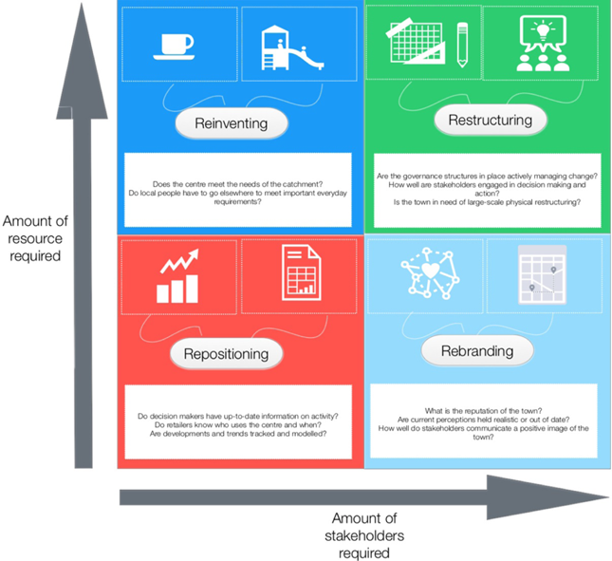
Academic studies show there are a wide variety of initiatives that can have an impact in different localities, such as the 25 priorities and 4Rs framework in the High Street UK 2020 project.

Business in the Community’s (BITC) Healthy High Streets programme supported 100 high streets across the UK between 2014-2017. It had some success in attracting business investment, jobs and footfall. Their toolkit sets out the measures they believe are successful.

Aditya Chakrabortty, has highlighted many local examples in his Guardian column. He emphasises the need to find new ways of democratising our economy, in an afterword to ‘The Making of a Democratic Economy’ by Marjorie Kelly and Ted Howard. Their principles of the democratic economy include:

- Community: The common good comes first. The self-contained individual does not exist, the community creates the conditions in which each of us may flourish.
- Inclusion: Creating opportunity for those long excluded. Particularly those excluded based on race, sex and wealth.
- Place: Building community wealth that stays local. Grounded in loyalty to a geographic place where working together for the common good instinctively makes sense.
- Good Work: Putting labour before capital with a living wage as a central aim.
- Democratised ownership: Enterprises are understood to be human communities. They operate at an appropriate scale with living missions and with decision making by moral agents. This is more likely when ownership is locally rooted and close to daily operations.
- Sustainability: Humans are not masters of the world but members of it. The extractive economy is waging war on nature. The democratic economy understands that we must meet present needs without compromising the ability of those in the future to meet their needs.
- Ethical Finance: Investing and lending for people and place. Bringing money back to the real world, reaching actual companies to fund operations – not the casino economy of speculative trading.

The pandemic has also highlighted what the retail guru, Mary Portas, calls the ‘Kindness Economy’. For those who can afford to shop around, the companies that have proved heroes could find that the goodwill towards their brand lasts. On social media, it is clear that some companies have tarnished their reputations in the way they have reacted to the crisis, usually in their treatment of staff, while others have impressed people. You can see this in the local Facebook pages with people contrasting the actions of local firms with the behaviour of some big national brands.

Mark Carney, the former governor of the Bank of England, who recently suggested the shift in values that would be sparked by the crisis. Writing in the Economist, he said: ‘Fundamentally, the traditional drivers of value have been shaken, new ones will gain prominence, and there’s a possibility that the gulf between what markets value and what people value will close.’

Many people turned to local suppliers during the pandemic. It remains to be seen if this leads to longer-lasting changes in shopping habits. Dumfries and Galloway Council is undertaking a study on this issue, which may highlight lessons for other areas. It has been argued that greater use of Britain’s 1,173 markets could support local suppliers. Markets employ more people per sq metre of space than supermarkets, distribute their economic profits locally and add footfall and vibrancy to high streets. They build local wealth and promote a more sustainable economy and society by reducing waste, shortening supply chains and reducing car-based consumption.

The Jimmy Reid Foundation paper, ‘Municipal Socialism for Modern Scotland’, sets out a modern approach to municipal socialism. Not just more efficient service delivery or to raise revenues, but as part of creating a fairer society. It highlights a range of services that could be delivered by local government in partnership with local community ownership and co-operatives.

A number of communities across Scotland have taken over their local pub. The community-owned pub enhances the experience of being part of a community, one that works together for the common good, which can achieve great things when local people unite and decide to build something positive and lasting for the future.

At a local level, the wealth generated by workers, local people, communities, local enterprise and business in our towns and cities does not flow back to them but instead is often extracted by distant shareholders as profits and dividends. Large amounts of public money have also been poured into some areas in the hope that it will trickle down to the people who live there - when in practice much of that money didn’t stay there.

Community Wealth Building (CWB) seeks to address this by encouraging plural ownership of the local economy, increasing investment in local economies using fair employment, progressive procurement and the socially just use of land and property. This includes directly managing services previously outsourced to large companies remote from the community.

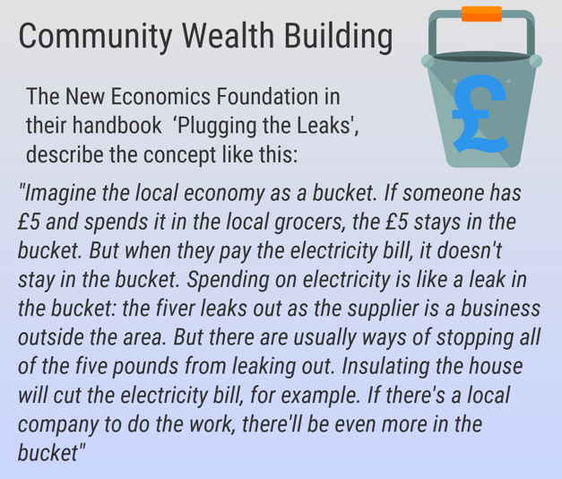
The Preston Model is the best-known example of this is the UK. They have worked with local anchor institutions such as universities and hospitals, as well as through its own procurement practices, to ensure a greater share of the money it spends stays in the local economy. North Ayrshire Council has recently published a five-year Community Wealth Building Strategy, the first of its kind in Scotland sets out their ambitions to become a Community Wealth Building Council.

The strategy argues that the answer is no longer traditional economic growth, ‘we need a new approach to our economy, centred on wellbeing and inclusion. A fair local economy must be central to our aims of tackling poverty and inequality.’

While the government measures are welcome, they have to be placed in the context of long-term underfunding of local government. Small pots of targeted cash are of limited value when the core services that our high streets need are being cut, year after year. To put the £50m Scottish Government fund into context; redundancy payments made by the UK Government for insolvent firms total more than £75m in Scotland alone. The recent Improvement Service benchmarking report detailed a 23% reduction in culture and leisure spending, 21% reduction in planning and a 28% reduction in economic development revenue spending. All services that are important to the high street.

The coronavirus pandemic has highlighted the limitations of globalisation. This includes the value chain concept, in which different companies add value to raw materials at each stage in the production process until they become finished goods. Increasingly, the stages have been spread across continents and countries. As a consequence, manufacturing in the UK declined from almost 30% of the economy in 1979 when Margaret Thatcher came to power to 10% today. The assumption was that so long as we moved up the value chain and remained able to pay for what was available, supply would never be short.

Brexit and the Trump trade wars started to flag up concerns. The supply of ventilators, PPE and the absence of a large diagnostics industry have undermined the response of governments in the UK to the pandemic. This is why countries like Germany and South Korea have managed to test more widely in accordance with WHO advice. After the pandemic, there is a strong case for rethinking our approach to global trade and focus more on the local.

The problems facing our high streets and town centres are not going to go away after the pandemic measures are relaxed and the economic support ends. There will still be excess retail capacity in many high streets, and many consumers may regard on-line shopping as a safer and more convenient option. Although bricks and mortar stores are still two and a half times more likely to sell to customers who visit them. As a consequence, we need to rethink our town centres as places where people live and work, not just shop. This needs more than a few local initiatives. It requires a regeneration programme that redevelops redundant retail spaces and car parks into homes, workplaces, community hubs and social spaces. If buildings lie empty for too long, councils should take them over and repurpose them.

Academy of Urbanism – 5 Steps to recovery

- Action Get Smart: Local authorities should use the power of digital technology to promote recovery. Mapping will help in setting priorities, for example identifying isolated and disadvantaged areas. Shops and eating places that offer good service should be highlighted.

- Access Reallocate space: Priority for should be given to ‘active travel’ (walking and cycling) which means ‘taming’ cars and promoting better integrated public transport. We should reallocate road space, as Copenhagen did, but also make short-term parking easier or ‘free after 3.00’. Local authorities could take back the bus services and promote better local rail services. Funding could come from charging out-of-town stores for parking when the business rate is reassessed.

- Attractions Open empty shops: Redundant peripheral retail premises and surplus car parks need to be redeveloped as homes, workplaces and community hubs or social spaces. Local authorities should take over key buildings if they lie empty too long, as happened in bomb damaged Comprehensive Development Areas after the Second World War.

- Amenity Promote special places: Streets and neighbourhoods with a distinct character, for example clusters of shops or services or waterfronts, should be boosted. Festivals and campaigns can help. Environmental upgrades should counter the lure of out-of-town retail parks but go beyond expensive facelifts that are like ‘putting lipstick on a corpse’. Spreading the benefits of regeneration must reignite civic pride.

- Agency Re-empower local authorities: Most important of all government must as a matter of urgency release the resources for town centres to revive by recasting parking charges and property taxes. The time is ripe to rethink what town centres are for, and for a multitude of pilot projects.

Sustainable Communities

As we hopefully ‘Build Back Better’ from the pandemic, the climate emergency remains with us. Terrible though the pandemic is, the climate emergency has the potential to kill far more people. This means that any plan to build stronger communities has to have sustainability at its heart.

The measures taken by governments to contain the pandemic have resulted in some breathing space for the environment. Most notably it will have saved some of the estimated 2,500 unnecessary deaths each year from air pollution in Scotland. Some cities have seen a 60% reduction in traffic-related air pollution.

Scotland has ambitious targets to tackle climate change. We now need equally ambitious action and communities need to be at the heart of that change. Many of the measures identified in this paper to build stronger communities will also contribute to climate change action plans.

An emphasis on the local economy through Community Wealth Building will reduce transport pressures and support a circular economy, which leads to zero waste, developing local industries rather than relying on global supply chains. Rather than buying goods on international markets, using them and then landfilling them only to repeat the process, we need to make sure that all resources are reused and recycled. A sharing economy is much easier to develop in strong communities, rather than buying goods we rarely use, manufactured far away.

Town centres that are accessible by effective and affordable public transport, rather than cars, will reduce emissions. Active travel plans prioritise encouraging and enabling people to get out of their cars, onto bikes, walking and public transport, for better health and a cleaner environment. A shift from commuting to our major cities with more home working could bring cleaner air and potentially a more productive and happier workforce.

Our highly centralised and privatised energy system has failed consumers and the economy. Most of the benefits from renewable energy developments leave the local economy, and genuine community energy projects make up a small proportion of generation capacity. Even the modest Scottish Government targets are unlikely to be realised. A national energy company should give direction and inject investment on a large scale but also help develop new generation capacity, with local supply chains, engaging councils and local communities under common, community and cooperative ownership. The key concept behind local energy economies is to balance local generation with local demand and to create system flexibility for times when the two don’t match.

The heating of buildings is responsible for similar emissions to transport and agriculture. The housing programme identified above should include a minimum standard of energy efficiency in all housing tenures of an EPC rating of at least C by 2025. Such investment and regulation is also an opportunity to support the transition to low-carbon heat technologies.

Local food production, together with established low carbon technologies, will be the key to reducing agricultural emissions. Post-Brexit agricultural support should be linked to the principle of public money for public goods, such as clean water and air, beautiful scenery, and biodiversity provision. The Government also has a wider role in supporting the necessary changes in our food system by supporting community growing and local food economies that help local businesses thrive and help everyone to access food produced in their local area. This includes the need to tackle food poverty effectively in a Good Food Nation Bill.

The pandemic has also highlighted the importance of green spaces in our communities. As we rebuild our town centres, we should take the opportunity to make them attractive and sustainable. That also means making a positive contribution to biodiversity.

Solutions are being offered all around us, in oft-underreported community projects and grassroots campaigns. In some cases whole communities are being created to experiment with greener and fairer ways of living. These are often a realistic antidote to the dystopian world that awaits us if change is not enacted faster and more radically. If a smogless New Delhi and a carless LA are no longer fantasies, not to mention Hope Street in Glasgow, then who knows what could be achieved in Scotland’s communities.

Funding communities

The funding of local government in Scotland has been a difficult issue for political parties. At best proposals have been sticking plaster solutions because change is viewed as being politically challenging. The last commission on local taxation also failed to get cross-party agreement.

There is an urgent need to reform the Council Tax, and the options are set out clearly in the commission report and the Jimmy Reid Foundation paper on public service reform. UNISON Scotland’s five principles remain a sound basis for reform:

- Local authorities should raise and control more of their own revenue. This will enable them to respond to and be more accountable to the communities they represent. About 85% of funding is currently determined centrally
- Councils should be able to set their own business rates, this will allow them to raise money to pay for services and devise their own criteria to support the type of businesses they want to encourage.
- A property tax is the best fit for local government as it is clearly linked to the authority. It cannot be moved or hidden making it cheap and easy for the local authority to administer.
- Central government funding should acknowledge local decision making and funds should be minimally ring-fenced.
- Taxation should be broadly progressive, reducing the tax incidence of people with a lower ability-to-pay. It doesn't mean every tax has to be progressive, but overall, those on higher incomes should pay more.

If progress on Council tax reform remains stymied, it is worth looking at other options to increase local funding.

The Jimmy Reid Foundation produced a paper for UNISON Scotland on this issue, which highlights a number of options.

These include a review of business rates, the reduction of which is a major demand of the business lobby. The Scottish Fiscal Commission calculates that business rates are likely to rise by 25% in the next three years, from £2.75bn this year to £3.4bn in 2023/24. This is largely due to 2017 re-evaluation appeals being settled, but will still be significant and highlights the importance of regular valuations.

The Small Business Bonus Scheme already provides relief from business rates for businesses where the rateable value of individual premises is £18,000 or less. This has created ‘rates deserts’ in some areas and the Barclay Review recommend a full evaluation. In Northern Ireland, an evaluation found the relief was misdirected and suggested it should be replaced with a relief more targeted on town centres. Any review of business rates should focus on how best to support private and social enterprise most effectively.

Another suggestion in the JRF report was to explore how new taxes and levies might support inclusive growth and community wealth building. Guy Standing, in his Plunder of the Commons (2019), makes a number of suggestions, which not only raise revenue but also encourage positive behaviours and discourage poor ones. One recommendation is the establishment of a Commons Fund, ﻿sourced by levies on the commercial use or exploitation of the commons. These levies would also give all citizens a sense of collective ownership, even if some cost them personally. Scotland has a long tradition of Common Good funds, which could be expanded on this basis.

A key issue is the taxation of digital services. Companies like Google and Amazon pay very low levels of Corporation Tax by adopting a variety of tax avoidance measures. This needs to be tackled in the UK and globally if there is to be a level playing field with the high street.

In Europe, local and regional community banks are commonplace, in comparison with our centralised banking system, which is more interested in investing in financial derivatives than the real economy. In Scotland, the New Economics Foundation (NEF) has worked with FoES and Common Weal to develop the concept of local and regional banks, supported by a National Investment Bank. The report shows that not only is a new banking system in Scotland possible despite powers over financial services being reserved to Westminster, but the capitalisation of a Scottish National Investment Bank of proportionate size to the German KfW is feasible within the Scottish Government's budget.

Regional banking is also a key aim of Community Wealth Building initiatives. Councils in North-West England are working with the Community Savings Bank Association and other stakeholders to set up a new regional bank. The stated aim is to keep money within the north-west and enable local lending in response to business needs. Many credit unions operate on a local basis and could provide the basis for strengthening the financial resilience of communities.

The pandemic will leave most councils with a financial headache as they have rightly focused on delivering key services. Not all the Barnett consequentials from local government spending have been passed on to Scottish councils, who will face longer-term challenges from a loss of income.

Stronger communities won’t happen without the necessary resources. As a nation, we have ducked these issues for too long.

Local Democracy

The Human Surveys report earlier this year highlighted a global dissatisfaction with democracy over the past 25 years. While this is most obvious in the Anglo-Saxon democracies like the UK, USA and Canada - other countries are bucking the trend including Denmark, Switzerland and the Netherlands. The authors highlight the polarisation brought about by majoritarian electoral systems; paralysis as in Brexit UK, corruption and scandal; and most relevant to this study – powerlessness. The authors argue that bolstering satisfaction in democracy will require addressing multiple issues. But acknowledging that democratic discontent has deeper roots is a necessary starting point.

Andy Cumbers in his book The Case for Economic Democracy makes the point that we think of democracy in political rather than economic terms. Yet, who controls our economy and makes the key decisions is fundamental to our lives. ﻿ His book discusses the steps needed to move from an economy driven by narrow self-interest and greed, towards a more democratic economy, capable of serving the common good.

Scotland has relatively large local authorities and some of the lowest voter turnout at local elections in the European Union. Important though local elections are, local democracy encompasses a wider engagement by people in the decisions that matter to their communities. As Fernando Cardoso puts it: ‘Democracy is not just a question of having a vote. It consists of strengthening each citizen’s possibility and capacity to participate in the deliberations involved in life in society.’

There have been many initiatives to strengthen local democracy in Scotland. The Christie Commission in 2011 set out the principles. Since then we have had parliamentary inquiries, legislation such as the Community Empowerment Act 2015, a review of community councils and the current Local Governance Review. They all start from the premise that people want to be more engaged but generally don’t feel part of the decision-making process.

Scotland has seven national standards for community engagement. These outline a set of practical measures which should underpin engagement activity. Significant effort and resources have been invested in participatory budgeting (PB), which aims to give local people a direct say in how public money is spent. PB is a growing movement worldwide and the Scottish approach has been to make grants available to facilitate community initiatives

The initiative has cross-party support. There is a commitment that 1% of council budgets will be subject to participatory budgeting by 2021 in an effort to mainstream the process.
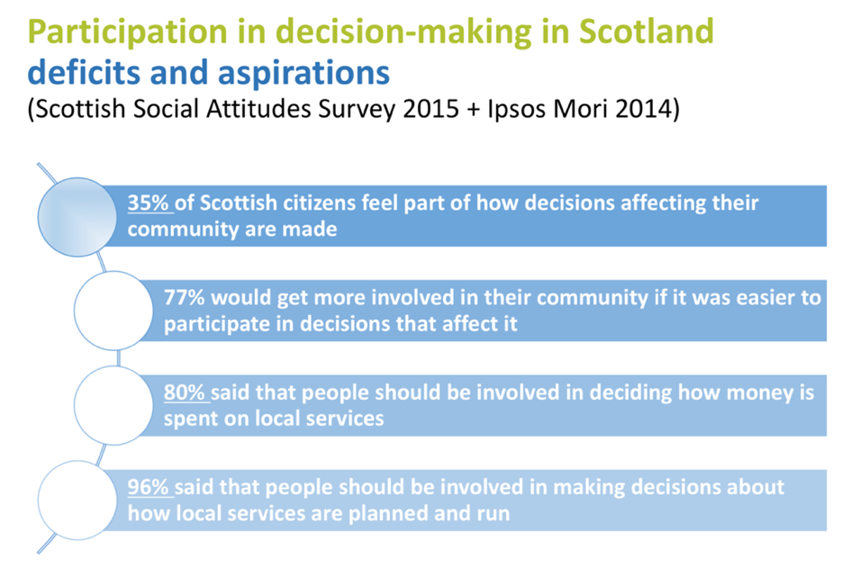
For PB to become central in local governance, and not just an add on, it must become part of how communities govern themselves. This means that participatory processes must be embedded within institutional arrangements. It also has to be properly resourced rather than being an additional task for already overstretched staff. Initial evaluation points to the cultural, capacity, leadership and political challenges PB brings. Not least the potential frictions between the democratic innovations of participatory democracy and established institutions of representative democracy.

The problem with many of the tools used to promote engagement is that are often skewed in favour of those in higher economic groups who have had a formal education. What we might call the inequalities of power and influence. The What Works Scotland evidence review on this argued that: ‘Groups that have been known in the past as 'hard to reach' are now more appropriately recognised as 'easy to ignore'. Those facing inequalities, sometimes multiple inequalities, are often easy to ignore due to the complexity of their situation, the difficulty of forming a solution and a lack of understanding from governments, organisations and programmes.’

They recommend a variety of different approaches tailored to the needs of specific communities. You start by listening to communities and then providing appropriate community-based support using a variety of techniques. It also has to be a long-term process.

These are all useful tools and approaches. However, we are arguably short of long-term evaluation of the application of these approaches. Scotland is littered with short-term initiatives.

Local democracy should sit alongside measures to decentralise powers and democratise the economy. A fairer Scotland where we care about each other, where people can pool their resources, demand accountability, build institutions and influence the decisions that affect them.

Conclusion

In this paper, we have sought to identify the factors that help build stronger communities. We have examined the many initiatives and ideas that have been generated in Scotland and across the world. It is clear that we don’t yet have all the answers, and further research is required in several key areas.

While many initiatives address specific factors, they may underestimate the challenges of austerity and now the impact of the pandemic. In low-income neighbourhoods, there is a need for the expansion of services to support physical and mental health, realistic assessments of capacity within communities, and the basic provision of neighbourhood services to enable community development.

The solutions have to be local and determined locally. The role of the Scottish Government is to set frameworks which enable communities to devise the solutions that best meet local need. That requires a political culture change in favour of subsidiarity.

We conclude that a comprehensive programme for stronger communities should include:

- Rebuilding the social infrastructure that provides the physical conditions that determine whether personal relationships can flourish.
- Ensuring that everyone has access to a decent standard of communication technology - devices and broadband.
- Building local integrated public services around service hubs in recognisable geographical communities.
- Recognising how place can improve health and wellbeing and focus health and social care services in localities.
- Repurpose our high streets and town centres as places where people live and work, not just shop, important though that will still be. This requires regeneration programmes to be broader and at a much larger scale.
- Community Wealth Building, based on wellbeing and inclusion, should be at the core of the measures needed to rebuild local economies.
- Regeneration must have sustainability at its core. Supporting local production, community energy, a sharing economy, public transport and active travel.
- Fair funding for local government, both through grant allocations and the reform of local taxation. This includes the power to generate local revenues, including the use of revitalised Common Good funds.
- Decentralisation of power to local government and communities. That includes developing appropriate public engagement strategies for each community, with a focus on overcoming inequalities of power and influence.

Stronger communities will not happen by accident or by more political rhetoric and high-level principles. We need a comprehensive programme of action that covers all the factors that help build stronger communities.

McMillan, D.W. and Chavis, D.M. 1986. ‘Sense of community: A definition and theory,’
Rajan, Raghuram. ‘The Third Pillar 2019. ‘The Revival of Community in a Polarised World’.
Alberti, F. https://theconversation.com/coronavirus-is-revitalising-the-concept-of-community-for-the-21st-century-135750
https://digitalpublications.parliament.scot/ResearchBriefings/Report/2020/6/24/Local-Government-Finance--Facts-and-Figures-2013-14-to-2020-21
https://www.improvementservice.org.uk/__data/assets/pdf_file/0013/12082/benchmarking-overview-report-2018-19.pdf
https://www.gov.scot/publications/2019-annual-report-welfare-reform/
https://www.savethechildren.org.uk/content/dam/gb/reports/evidence_of_families_needs.pdf
http://www.ccpscotland.org/wp-content/uploads/2018/12/Business-Resilience-Survey-2019.pdf
https://www.gov.scot/publications/social-capital-scotland-measuring-understanding-scotlands-social-connections/
http://unisondave.blogspot.com/2019/01/the-common-good.html
https://theconversation.com/after-coronavirus-how-seasonal-migration-and-empty-centres-might-change-our-cities-139439
https://scottishlabour.org.uk/wp-content/uploads/2019/10/Housing-Commission-final-report3.pdf
https://www.gov.scot/news/community-ownership-is-increasing-across-scotland/
https://www.westminster.ac.uk/news/westminster-research-project-london-soundings-showcases-sustainability-community-projects-across
https://thecaresfamily.org.uk/about
https://www.conter.co.uk/blog/2020/5/11/complex-solidarities-in-a-time-of-covid-19
https://www.gov.scot/publications/commission-future-delivery-public-services/
http://unisondave.blogspot.com/2016/06/christie-commission-five-years-on.html
http://reidfoundation.org/2017/01/public-service-reform-policy-paper-launched/public-service-reform-by-davewatson/
http://unisondave.blogspot.com/2019/12/financial-and-workforce-challenges-for.html
http://whatworksscotland.ac.uk/publications/rationales-for-place-based-approaches-in-scotland/
Commission on Local Democracy – https://issuu.com/cosla/docs/final_report_august_2014
http://www.healthscotland.scot/media/1394/place-standard-process-evaluation_may2017_english.pdf
https://www.rsph.org.uk/uploads/assets/uploaded/dbdbb8e5-4375-4143-a3bb7c6455f398de.pdf
https://theconversation.com/volunteering-mutual-aid-and-lockdown-has-shifted-our-sense-of-happiness-141352
https://digitalpublications.parliament.scot/Committees/Report/HS/2019/12/4/Social-Prescribing--physical-activity-is-an-investment--not-a-cost#Background-to-the-inquiry
https://commonweal.scot/policy-library/predictable-crisis
https://www.scotlandstowns.org
https://www.gov.scot/news/healthier-greener-town-centres/
https://www.gov.uk/government/publications/our-plan-for-the-high-street-budget-2018-brief
https://brc.org.uk/media/234065/the-future-of-scottish-retail.pdf
https://cms.usdaw.org.uk/retailstrategy.aspx
https://www.london.gov.uk/sites/default/files/ggbd_high_streets_adaptive_strategies_web_compressed_0.pdf
https://www.heraldscotland.com/news/18517032.scotlands-urban-buy-out-blueprint-towns/
https://www.emerald.com/insight/content/doi/10.1108/JPMD-03-2017-0032/full/html
https://www.bitc.org.uk/toolkit/people-places-and-pride-toolkit-practical-solutions-to-revitalise-your-high-street/
http://unisondave.blogspot.com/2019/07/the-making-of-democratic-economy.html
https://www.theguardian.com/lifeandstyle/2020/may/19/people-will-want-brands-that-reflect-their-values-mary-portas-on-how-lockdown-will-change-the-high-street
https://www.bbc.co.uk/news/uk-scotland-south-scotland-53021905
https://theconversation.com/coronavirus-recovery-why-local-markets-are-key-to-reviving-our-locked-down-town-centres-140510
http://reidfoundation.org/2018/05/new-policy-paper-municipal-socialism-for-modern-scotland-local-public-enterprise-for-the-common-good/
https://theconversation.com/coronavirus-could-accelerate-dying-pub-culture-is-community-ownership-the-answer-136996
https://cles.org.uk/wp-content/uploads/2019/09/CWB2019FINAL-web.pdf
https://www.north-ayrshire.gov.uk/Documents/nac-cwb-strategy-brochure.pdf
https://journal.academyofurbanism.org.uk/news/reinventing-town-centres/
https://www.communityenergyscotland.org.uk/local-energy-economies.asp
https://journal.academyofurbanism.org.uk/climate-emergency/communities-have-climate-solutions-now-cities-must-let-them-thrive/
https://theconversation.com/these-communities-are-experimenting-with-greener-and-fairer-ways-of-living-129374
Commission on Local Tax Reform – Final Report Dec 2015 - http://localtaxcommission.scot
http://reidfoundation.org/2019/04/unison-scotland-commissioned-report-on-alternative-sources-of-funding-for-local-government/
http://unisondave.blogspot.com/2019/09/plunder-of-commons.html
https://www.gov.scot/publications/land-reform-review-group-final-report-land-scotland-common-good/pages/36/
https://www.commonspace.scot/articles/3641/new-report-banking-common-good
https://www.bennettinstitute.cam.ac.uk/publications/global-satisfaction-democracy-report-2020/
http://unisondave.blogspot.com/2020/05/the-case-for-economic-democracy.html
https://www.scdc.org.uk/what/national-standards/
https://pbscotland.scot
http://whatworksscotland.ac.uk/wp-content/uploads/2017/12/WWSHardToReachOrEasyToIgnoreEvidenceReview.pdf

